**Request for Proposal (RFP) for Management Professional Services - Cover Letter**

**RFP 2024-12.10**

*12/10/2024*

Re: Community Wildfire Defense Grant (CWDG) project(s) as part of funding announcement [USDA-FS-2024-CWDG-SGSF](https://www.grants.gov/web/grants/view-opportunity.html?oppId=349610) which is managed by the National Forest Service (NFS) for Round 3.

Dear Service Providers:

Attached is a copy of the Trinity County’s Request for Proposals (“RFP”) for *professional management services.* These services are being solicited to assist Trinity County in its application(s) for and implementation of a contract, if awarded, from the Community Wildfire Defense Grant (CWDG)program. Trinity County is considering applying for such funding for wildfire prevention, education, outreach, hazardous fuels reduction, restoration projects and management activities as indicated in the attached Scope of Work.

Service providers may submit proposals for any or all activities listed in the attached Scope of Work. Trinity County will, in its sole discretion, determine the contract to be awarded, and may decide not to award any contract.

The submission requirements for this proposal are included in the attached RFP. Please e-mail a proposal of services and statement of qualifications to:

*Email address: vicki.branch@co.trinity.tx.us*

The deadline for submission of proposals December 30, 2024 @ 10:00 A.M. It is the responsibility of the submitting entity to ensure that the proposal is received in a timely manner. Proposals received after the deadline will not be considered for award, regardless of whether or not the delay was outside the control of the submitting provider. Trinity County reserves the right to negotiate with any and all service providers submitting timely proposals.

Trinity County is an Affirmative Action/Equal Opportunity Employer. Section 3 Residents, Minority Business Enterprises, Small Business Enterprises, Women Business Enterprises, and Labor Surplus Area firms are encouraged to submit proposals.

Sincerely,

______________________

*Vicki Branch*

*Grant Writer @ Trinity County*

*vicki.branch@co.trinity.tx.us*

**RFP for Management Professional Services**

Trinity County is seeking well-qualified management/activity delivery service provider(s) to assist Trinity County in preparing application(s) for and in the overall management and implementation of proposed Community Wildfire Defense Grant (CWDG) project, if funded, by the National Forest Service (NFS) through USDA. The following outlines the RFP:

1. Scope of Work

***Management Services***

A sample detailed Scope of Work (“SOW”) for CWDG management services is enclosed in this packet (*see* pages 7-9). The management service provider to be hired will provide application and contract-related management services, including but not limited to the following areas:

Pre-Funding Services

Provider will assist in developing project scope(s) and complete CWDG application. The provider will work with the local government and Engineer, if applicable, to provide the concise information needed for submission of a CWDG application and related documents. The required information shall be submitted in a format to be described by the National Forest Service.

Post-Funding Services

Provider will manage and provide activity delivery of eligible projects as outlined by the CWDG application/guidance and funded by the National Forest Service. The selected service provider must follow all requirements of the CWDG program as administered by the NFS.

General management Services

* Administrative Duties
* Labor Management including Labor Standards (Davis-Bacon Wage Rate activities)
* Acquisition Duties (as necessary)
* Environmental Services

Please specify a complete list of actual tasks to be performed under each of these categories in your response, including, if necessary, a **brief** description of each task.

*\*Pre-funding services are ineligible for CWDG reimbursement.*

1. Statement of Qualifications

The City/County/District is seeking qualified professional management service providers experienced in grant application preparation, and management /activity delivery. Please provide the following as it relates to your qualifications :

* A brief history of the service provider, including general background, knowledge of and experience working with relevant agencies and programs;
* Related experience in applying for and managing federally-funded local projects, in particular recent experience;
* A description of work performance and experience with CWDG, Disaster Recovery Grants, FEMA Hazard Mitigation or similar projects including a list of at least three references from past local government clients, with information describing the relevancy of the previous performance;
* Describe which specific parts of the Scope of Work the service provider proposes to perform;
* Describe the capacity to perform the chosen Scope of Work activities as well as resumes of all employees who may be assigned to provide services if your firm is selected, identifying current employees and proposed hires; and
* A statement substantiating the resources of the service provider and the ability to carry out the scope of work requested within the proposed timeline.

1. Proposed Cost of Services

Provide your cost proposal to accomplish the scope of work by activity or to complete a specific service outlined above and for any additional services required using the Cost of Services page(s) included in this packet: Required RFP Forms. The specific projects and grant amounts are yet to be determined; therefore, vendors should propose pricing based on the potential funding amounts provided.

The local government will consider dividing total requirements, when economically feasible, into smaller tasks or quantities to permit maximum participation by small and minority businesses, and women’s business enterprises. As such, proposers may specify any maximum limit to the total dollar value of grant funds they are able and willing to manage. Service providers may submit proposals for any or all activities. Preference will be given to firm fixed pricing. The proposal must include all costs that are necessary to successfully complete these activities. Note that the lowest/best price proposal will not be used as the sole basis for entering into this contract; rather, award will be made to the service provider(s) providing the best value, cost and other factors considered. The local government reserves the right to negotiated pricing.

*Upon the award of this contract, profit (either %/actual cost) must be identified and negotiated as a separate element of the price for any contract in excess of $50,000.00*.

1. Evaluation Criteria - The proposal received will be evaluated and ranked according to the following criteria and using the rating sheet enclosed:

|  |  |  |  |
| --- | --- | --- | --- |
|  |  |  |  |

|  |  |  |
| --- | --- | --- |
| **Criteria** |  | **Maximum Points** |
| Experience of the Firm |  | 30 |
| Prior Work Performance |  | 25 |
| Capacity to Perform |  | 30 |
| Historically Underutilized Business HUB) |  | 10 |
| Proposed Cost |  | 5 |
| **Total** |  | 100 |

|  |  |  |  |
| --- | --- | --- | --- |
|  |  |  |  |

1. Submission Requirements

* A copy of your current **certificate of insurance** for professional liability.
* **Statement of Conflicts of Interest** (if any) the service provider or key employees may have regarding these services, and a plan for mitigating the conflict(s). Note that City/County/District may in its sole discretion determine whether or not a conflict disqualifies a firm, and/or whether or not a conflict mitigation plan is acceptable.
* **System for Award Management. Service provider must have a current registration in the System for Award Management (**[**https://www.sam.gov/SAM/**](https://www.sam.gov/SAM/)**). Service provider and its Principals, may not be debarred or suspended nor otherwise on the Excluded Parties List System (EPLS) in the System for Award Management (SAM). Include verification that the service provider as well as its principals are not listed (are not debarred) through the System for Award Management (www.SAM.gov). Enclose a printout of the search results that includes the record date. This clearance information must be included in the service provider’s Proposal.**
* **Form CIQ,** (enclosed). Texas Local Government Code chapter 176 requires that any vendor or person who enters or seeks to enter into a contract with a local government entity disclose in the Questionnaire Form CIQ the vendor or person’s employment, affiliation, business relationship, family relationship or provision of gifts that might cause a conflict of interest with a local government entity. Questionnaire form CIQ is included in the RFP and must be submitted with the response. **Certification Regarding Lobbying (**enclosed). Certification for Contracts, Grants, Loans, and Cooperative Agreements is included in the RFP and must be submitted with the response.
* **Form 1295,** (enclosed). Effective January 1,2018, all contracts and contract amendments, extensions, or renewals executed by the Commissioners Court will require the completion of Form 1295 “Certificate of Interested Parties” pursuant to Government Code § 2252.908. Form 1295 must be completed by the awarded vendor at time of signed contract submission. Form 1295 is included in this RFP for your information. Form 1295 requires the inclusion of an “unsworn declaration” which includes, among other things, the date of birth and address of the authorized representative signing the form.
* **Required Contract Provisions**. Applicable provisions (enclosed) must be included in all contracts executed as a result of this RFP.

1. Contracting with minority businesses, women's business enterprises, and labor surplus area firms. Small and minority businesses, women's business enterprises, and labor surplus area firms ***must*** participate in this RFP. If the awarded vendor is a prime contractor and may use subcontractors, the following affirmative steps are required of the prime contractor:
2. Placing qualified minority businesses and women's business enterprises on solicitation lists;
3. Assuring that minority businesses, and women's business enterprises are solicited whenever they are potential sources;
4. Dividing total requirements, when economically feasible, into smaller tasks or quantities to permit maximum participation by minority businesses, and women's business enterprises;
5. Establishing delivery schedules, where the requirement permits, which encourage participation by minority businesses, and women's business enterprises;
6. Using the services and assistance, as appropriate, of such organizations as the Small Business Administration (SBA) and the Minority Business Development Agency (MBDA) of the Department of Commerce.
7. **Please choose the MBDA Center that is in closest proximity to your community. Email your RFP to the appropriate center.**

Minority-owned businesses may be eligible for contract procurement assistance with public and private sector entities from MBDA centers:

|  |  |
| --- | --- |
| Dallas MBDA Business Center | Houston MBDA Business Center |
| 8828 N. Stemmons Freeway, Ste. 550B | 3100 Main Street, Ste. 701 |
| Dallas, TX 75247 | Houston, TX 77002 |
| 214-920-2436 | 713-718-8974 |
| Website: https://www.mbdadfw.com | Website: https://www.mbda.gov/business-center/houston-mbda-business-center |
| Email: admin1@mbdadallas.com | Email: MBDA@hccs.edu |
|  |  |
| El Paso MBDA Business Center | San Antonio MBDA Business Center |
| 2401 East Missouri Avenue | 501 W. Cesar E. Chavez Blvd., Ste. 3.324B |
| El Paso, TX 79903 | San Antonio, TX 78207 |
| 915-351-6232 | 210-458-2480 |
| Website: https://www.mbda.gov/business-center/el-paso-mbda-business-center | Website: https://www.mbda.gov/business-center/san-antonio-mbda-business-center |
| Email: treed@ephcc.org | Email: orestes.hubbard@utsa.edu |

Woman-owned businesses may be eligible for assistance from SBA Women’s Business Centers:

|  |  |
| --- | --- |
| Dallas Fort Worth WBC | WBEA – Women’s Business Center |
| 7800 N. Stemmons Fwy., Ste. 120 | 9800 Northwest Freeway, Ste. 120 |
| Dallas, TX 75247 | Houston, TX 77092 |
| 214-572-9452 | 713-681-9232 |
| Website: https://womensbusinesscenterdfw.com/ | Website: https://www.wbea-texas.org/womens-business-center |
| Email: wbcdfw@liftfund.com | Email: wbc@wbea-texas.org |
|  |  |
| LiftFund Women’s Business Center |  |
| 600 Soledad St. |  |
| San Antonio, TX 78205 |  |
| 888-215-2373 ext. 3000 |  |
| Website: https://womensbusinesscentersa.com/ |  |
| Email: wbc@liftfund.com |  |

1. Deadline for Submission – Proposals must be received no later than December 30, 2024 at 10:00 A.M. . It is the responsibility of the submitting entity to ensure that the proposal is received in a timely manner. Proposals received after the deadline will not be considered for award, regardless of whether or not the delay was outside the control of the submitting firm.

Please electronically submit your proposal in .pdf format via email to vicki.branch@co.trinity.tx.us*.* Proposals must be received by Trinity County no later than 10:00 A.M. on December 30, 2024 to be considered.

Any questions or requests for clarification must be submitted in writing via EMAIL to the address above at least 3 business days prior to the deadline. Trinity County may, if appropriate, circulate the question and answer to all service providers submitted proposals.

**SCOPE OF WORK**

**Management Services**

The Contractor shall provide the following scope of services:

**SCOPE OF SERVICES REQUESTED**

Providers will help the NFS fulfill State and Federal statutory responsibilities related to Wildfire Mitigation. Providers will assist the NFS and grant recipients in completion of approved mitigation project(s) through the CWDG program. Respondents may be qualified to provide Grant Management services for one or more programs or services (environmental, acquisition/buyout, general management, etc.) Grant management services must be performed in compliance with the National Forest Service through the U.S. Department of Agriculture (USDA) and guidelines issued by the NFS.

**DESCRIPTION OF SERVICES AND SPECIAL CONDITIONS**

Respondent must be able to perform the tasks listed herein to be considered eligible for an award under this Solicitation. Respondents should provide a detailed narrative of their experience as it relates to each of the items below. Respondents should clearly indicate if they intend to provide services in-house with existing staff or through subcontracting or partnership arrangements. Grant Management Services will be provided in conformance with the guidance documents and use forms provided by the subrecipient utilizing NFS guidance. The providers shall furnish pre-funding and post-funding grant administrative services to complete the CWDG project(s), including, but not limited to the following:

**Pre-Funding Services**

Provider will assist in developing project scope(s) and complete CWDG application. The provider will work with the local government and Engineer, if applicable, to provide the concise information needed for submission of a CWDG application and related documents. The required information shall be submitted in a format to be described by the National Forest Service.

**Post-Funding Services**

Grant Administrator will provide Grant Management Services required to complete CWDG project, with funding. The selected service provider must follow all requirements of the as established by the National Forest Service.

**Grant Management Services**

1. General Management Duties:
   1. Ensure program compliance including all CWDG requirements and all parts therein, current Federal Register, etc.
   2. Assist subrecipient in establishing and maintaining financial processes.
   3. Obtain and maintain copies of the subrecipient’s most current contract including all related change requests, revisions and attachments.
   4. Establish and maintain record keeping systems.
   5. Assist subrecipient with resolving monitoring and audit findings.
   6. Serve as monitoring liaison.
   7. Assist subrecipient with resolving third party claims.
   8. Report suspected fraud to the NFS.
   9. Submit timely responses to the NFS requests for additional information.
   10. Complete draw request forms and supporting documents.
   11. Facilitate outreach efforts, application intake, and eligibility review.
   12. Utilize and assist with NFS’s system of record to complete milestones, submit documentation, reports, draws, change requests, etc.
   13. Submit change requests and all required documentation related to any change requests.
   14. Coordinate, as necessary, between subrecipient and any other appropriate service providers (i.e. Engineer, Environmental, etc.), contractor, subcontractor and NFS to effectuate the services requested.
   15. May assist in public hearings.
   16. Will work with NFS’s system of record.
   17. Provide monthly project status updates.
   18. Funding release will be based on deliverables identified in the contract.
   19. Labor and procurement duties:
       1. Provide all Labor Standards Officer (LSO) Services.
       2. Ensure compliance with all relevant labor standards regulations.
       3. Ensure compliance with procurement regulations and policies.
       4. Maintain document files to support compliance.
   20. Financial duties:
       1. Prepare and submit all required reports
       2. Assist subrecipient with the procurement of audit services.
       3. Assist subrecipient in establishing and maintaining a bank account for program funds.
       4. Program compliance.
       5. Ensure that fraud prevention and abuse practices are in place and being implemented.
       6. Prepare and submit all closeout documents.
       7. Submit all invoices no later than 60 days after the expiration of the contract..
       8. Assist in preparation of contract revisions and supporting documents including but not limited to:
          * Amendments/modifications,
          * Change orders.
   21. Perform any other administrative duty required to deliver the project.
2. Labor Management
   1. The provider will assist the subrecipient in submitting/setting up project applications in the NFS’s system of record.
   2. The provider may compile and collate complete contract/bid packages that meet NFS program requirements. The packages will contain supporting documentation that meets or exceeds the requirements of the NFS’s program. If applications do not have the necessary forms, the provider may assist the subrecipient by coordinating to acquire the necessary documentation.
   3. The provider may monitor, report, and evaluate contractor's performance; notify the subrecipient if the contractor(s) fails to meet established scheduled milestones. Receive, review, recommend, and process any change orders as appropriate to the individual projects.
   4. The provider may assist the subrecipient with project Activity Draws/Close Out.
   5. The provider may assist the subrecipient by submitting all the necessary documentation for draws and to close a project activity in the NFS’s system of record. The provider will compile, review for completeness, and collate complete contract/closeout packages that meet NFS program requirements for draw requests. If applications do not have the necessary forms, the provider may assist the subrecipient by coordinating to acquire the necessary documentation.
   6. The provider may assist the subrecipient in developing Architectural and Engineering plans with guidance from the NFS.
   7. Reassignment scope alignment (if necessary).
3. Acquisition Duties:
   1. Submit acquisition reports and related documents.
   2. Establish acquisition files (if necessary).
   3. Complete acquisition activities (if necessary).
4. Buyout Duties (as necessary):
   1. Project planning, design, and startup
      * + Assist subrecipient with procuring necessary vendors including appraiser, title vendor, and demolition contractor.
        + Develop subrecipient’s Policy and Procedure Manual ("Program Guidelines") and manage subsequent public comment processes.
   2. Property owner notifications
      * + Generate and send required mailings to owners and tenants of each parcel targeted for buyout/acquisition.
        + Handle subsequent communication with owners and tenants while developing a contact log for future outreach.
   3. Intake meetings
      * + Advertise, schedule, and conduct intake with interested homeowners.  During intake meetings case managers will collect all available documentation necessary to determine eligibility.
        + If there are tenants living in the property, case manager will send them General Information Notices to inform them of the program and their rights.
   4. Eligibility verification
      * + Management staff will review all intake documentation and verify eligibility.
        + If applicable, firm will verify duplicative benefits (DOB) and calculate eligible receipts.
        + Maintain applicant data in a secure system of record and comply with all record-keeping requirements of the General Land Office.
   5. Environmental reviews and site specific clearances
      * + Conduct all required environmental reviews (Tier I and Tier II) and generate environmental clearance reports for each applicant file.
   6. Offer package generation, approval, and mailing
      * + Notify subrecipient that offer packages are ready, and use independently procured appraisals to determine the fair market value of buyout properties.
        + Generate and mail offer packages upon the subrecipient approval.
   7. Offer meeting
      * + Schedule and conduct offer meetings with property owners to discuss their options; accept, appeal or decline.
        + If the owner decides to appeal, the case manager will provide advisory services to guide owner through appeal process.
        + If the owner accepts, a contract of sale will be signed at the offer meeting.
   8. Closing
      * + Coordinate with property owner and subrecipient's procured title company to ensure the clear passage of title.
        + Assist property owner with relocation arrangements and schedule real estate closing.
   9. Draw/funding requests
      * + Assist subrecipient with NFS draw requests, funding requests, wire tracking, and coordinating program activities to align with funding schedule.
   10. File, audit, closeout, and demolition
       * + Complete final audit to ensure all procedures were properly followed.
         + Transfer physical files to subrecipient and complete remaining data entry.
         + Provide procured demolition contractor with property access.
5. Environmental Services
   * 1. Review each project description to ascertain and/or verify the level of environmental review required: Exempt, Categorical Exclusion not Subject to 58.5, Categorical Exclusion Subject to 58.5, Environmental Assessment, and Environmental Impact Statements;
   1. If necessary, conduct tiered environmental review and submit broad and site-specific environmental reviews as required by 24 CFR Part 58.
      1. Prepare, complete and submit required forms for environmental review and provide all documentation to support environmental findings;
      2. Consult and coordinate with oversight/regulatory agencies to facilitate environmental clearance;
      3. Be able to perform or contract special studies, additional assessments, or permitting to secure environmental clearance. These may include, but are not limited to biological assessments, wetland delineations, asbestos surveys, lead-based paint assessments, archeology studies, architectural reviews, Phase I & II ESAs, USACE permits, etc.;
      4. Prepare all responses to comments received during comment phase of the environmental review, including State/Federal Agency requiring further studies and/or comments from public or private entities during public comment period;
      5. Maintain close coordination with local officials, project engineer, if applicable, and other members of the project team to assure appropriate level of environmental review is performed and no work is conducted without authorization;
      6. Complete and submit the environmental review into NFS’s system of record;
      7. At least one site visit to project location and completion of a field observation report;
      8. Prepare and submit for publication all public notices including, but not limited to the Notice of Finding of No Significant Impact (FONSI), Request for Release of Funds floodplain/wetland early and final notices in required order and sequence;
      9. Provide documentation of clearance for Parties Known to be Interested as required by 24 CFR 58.43;
      10. Process environmental review and clearance in accordance with NEPA;
      11. Advise and complete environmental re-evaluations per 24 CFR 58.47 when evidence of further clearance or assessment is required;
      12. Prepare and submit Monthly Status Report; and
      13. Participate in regularly scheduled progress meetings.

**Management Professional Services Rating Sheet**

**NFS CWDG-MOD**

|  |
| --- |
|  |

**Rate the Firm’s Proposal in the following areas:**

|  |  |  |
| --- | --- | --- |
| **A. Experience and Qualifications** | **Points**  **Possible** | **Points**  **Awarded** |
| 1. Experience with application grant writing and project delivery services for State and Federally funded projects. | 15 |  |
| 2. Experience working with the Cities and Counties | 15 |  |
| ***SUBTOTAL*** | ***30*** |  |

|  |  |  |
| --- | --- | --- |
| **B. Work Performance (references and prior experience with firm)** | **Points**  **Possible** | **Points**  **Awarded** |
| 1. Work product is consistently of high quality | 5 |  |
| 2. Facilitates completion of project activities on schedule | 5 |  |
| 3. Understands the approach for project implementation | 5 |  |
| 4. References from current/past clients | 10 |  |
| ***SUBTOTAL*** | ***25*** |  |

|  |  |  |
| --- | --- | --- |
| **C. Capacity to Perform** | **Points**  **Possible** | **Points**  **Awarded** |
| 1. Staffing level/experience, special skills | 15 |  |
| 2. Understanding of CWDG | 15 |  |
| ***SUBTOTAL*** | ***30*** |  |
| **D. Proposed Fee** | **Points**  **Possible** | **Points**  **Awarded** |
| 1. Price is reasonable considering the firm’s experience and qualifications | 5 |  |
| ***SUBTOTAL*** | ***5*** |  |

|  |  |  |
| --- | --- | --- |
| **E. Affirmative Action** | **Points**  **Possible** | **Points**  **Awarded** |
| 1. Firm is a Historically Underutilized Business (Include Comptroller Cert in proposal) | 10 |  |
| ***SUBTOTAL*** | ***10*** |  |

|  |  |  |
| --- | --- | --- |
| **Scoring Summary:** | **Points**  **Possible** | **Points**  **Awarded** |
| A. Experience of firm | 30 |  |
| B. Work performance/program implementation | 25 |  |
| C. Capacity to perform | 30 |  |
| D. Proposed Fee | 5 |  |
| E. Affirmative Action | 10 |  |
| ***TOTAL SCORE*** | ***100*** |  |

**Insert current HUB certification if applicable**

**Insert Certificate of Insurance**

**Insert System for Award Management (SAM) record search for company name and company principal**

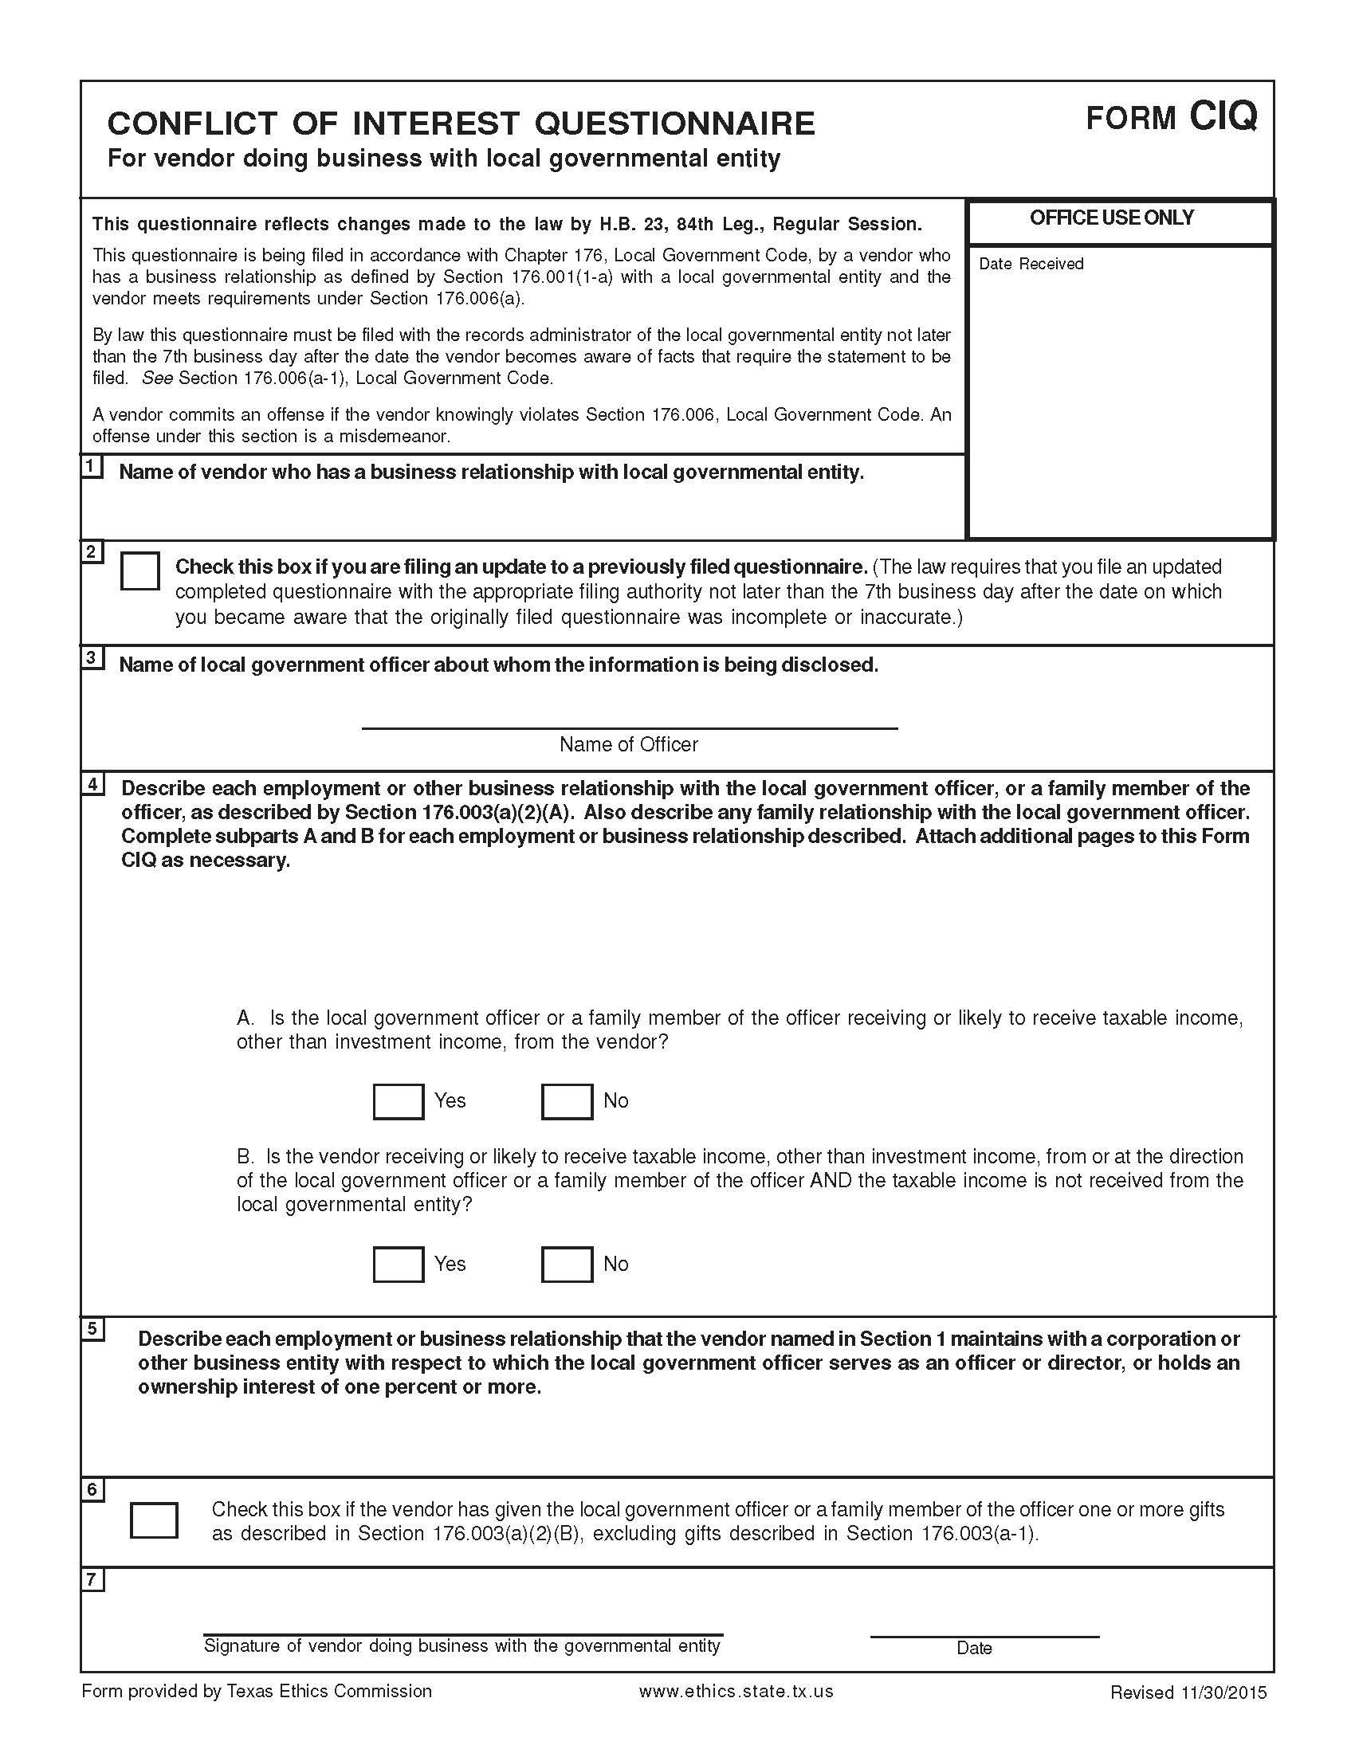

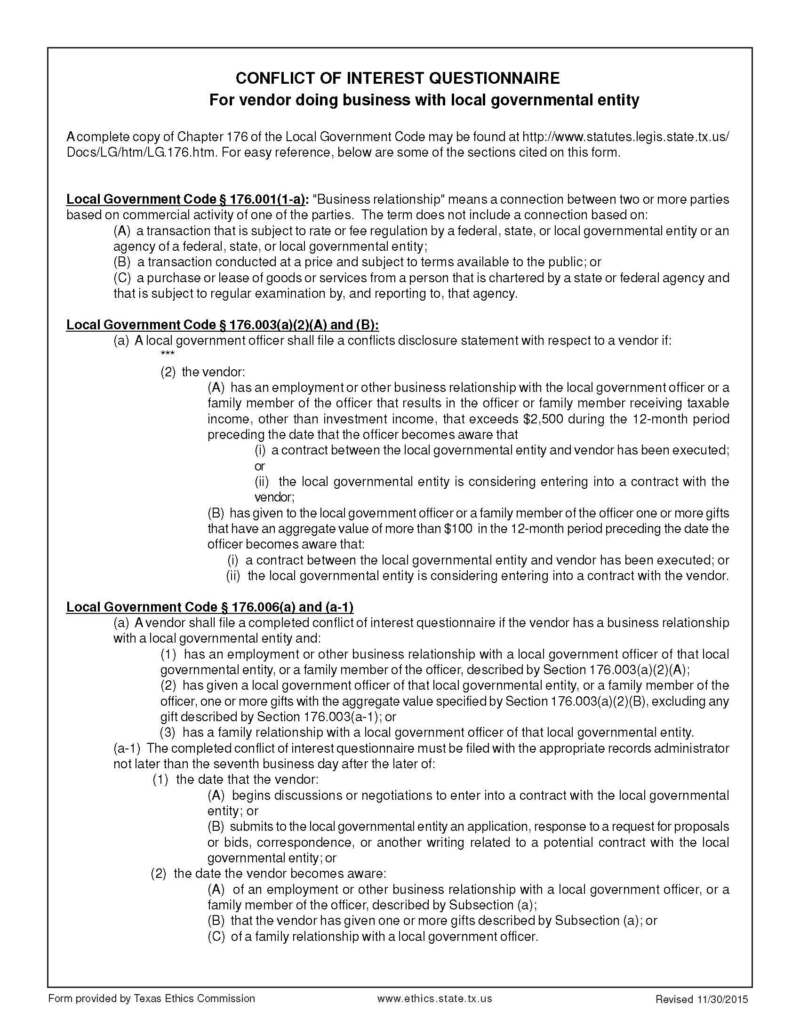

Certification Regarding Lobbying

(To be submitted with each bid or offer exceeding $100,000)

The undersigned certifies, to the best of his or her knowledge and belief, that:

(a) No Federal appropriated funds have been paid or will be paid, by or on behalf of the undersigned, to any person for influencing or attempting to influence an officer or employee of an agency, a Member of Congress, an officer or employee of Congress, or an employee of a Member of Congress in connection with the awarding of any Federal contract, the making of any Federal grant, the making of any Federal loan, the entering into of any cooperative agreement, and the extension, continuation, renewal, amendment, or modification of any Federal contract, grant, loan, or cooperative agreement.

(b) If any funds other than Federal appropriated funds have been paid or will be paid to any person for influencing or attempting to influence an officer or employee of any agency, a Member of Congress, an officer or employee of Congress, or an employee of a Member of Congress in connection with this Federal contract, grant, loan, or cooperative agreement, the undersigned shall complete and submit Standard Form-LLL, “Disclosure Form to Report Lobbying,” in accordance with its instructions.

(c) The undersigned shall require that the language paragraph 1 and 2 of this anti-lobbying certification be included in the award documents for all subawards at all tiers (including subcontracts, subgrants, and contracts under grants, loans, and cooperative agreements) and that all subrecipients shall certify and disclose accordingly.

This certification is a material representation of fact upon which reliance was placed when this transaction was made or entered into. Submission of this certification is a prerequisite for making or entering into this transaction imposed by 31, U.S.C. § 1352 (as amended by the Lobbying Disclosure Act of 1995).

The Contractor, ___________________, certifies or affirms the truthfulness and accuracy of each statement of its certification and disclosure, if any. In addition, the Contractor understands and agrees that the provisions of 31 U.S.C. § 3801 et seq., apply to this certification and disclosure, if any.

_____________________________________

Signature of Contractor’s Authorized Official

________________________________________________

Printed Name and Title of Contractor’s Authorized Official

_____________________________________

Date

**INSTRUCTIONS FOR COMPLETION OF SF-LLL, DISCLOSURE OF LOBBYING ACTIVITIES**

This disclosure form shall be completed by the reporting entity, whether subawardee or prime Federal recipient, at the initiation or receipt of a covered Federal action, or a material change to a previous filing, pursuant to title 31 U.S.C. section 1352. The filing of a form is required for each payment or agreement to make payment to any lobbying entity for influencing or attempting to influence an officer or employee of any agency, a Member of Congress, an officer or employee of Congress, or an employee of a Member of Congress in connection with a covered Federal action. Complete all items that apply for both the initial filing and material change report. Refer to the implementing guidance published by the Office of Management and Budget for additional information.

1. Identify the type of covered Federal action for which lobbying activity is and/or has been secured to influence the outcome of a covered Federal action.

2. Identify the status of the covered Federal action.

3. Identify the appropriate classification of this report. If this is a follow-up report caused by a material change to the information previously reported, enter the year and quarter in which the change occurred. Enter the date of the last previously submitted report by this reporting entity for this covered Federal action.

4. Enter the full name, address, city, State and zip code of the reporting entity. Include Congressional District, if known. Check the appropriate classification of the reporting entity that designates if it is, or expects to be, a prime or subaward recipient. Identify the tier of the sub awardee, e.g., the first sub awardee of the prime is the 1st tier. Subawards include but are not limited to subcontracts, subgrants and contract awards under grants.

5. If the organization filing the report in item 4 checks “Sub awardee,” then enter the full name, address, city, State and zip code of the prime Federal recipient. Include Congressional District, if known.

6. Enter the name of the federal agency making the award or loan commitment. Include at least one organizational level below agency name, if known. For example, Department of Transportation, United States Coast Guard.

7. Enter the Federal program name or description for the covered Federal action (item 1). If known, enter the full Catalog of Federal Domestic Assistance (CFDA) number for grants, cooperative agreements, loans, and loan commitments.

8. Enter the most appropriate Federal identifying number available for the Federal action identified in item 1 (e.g., Request for Proposal (RFP) number; Invitations for Bid (IFB) number; grant announcement number; the contract, grant, or loan award number; the application/proposal control number assigned by the Federal agency). Included prefixes, e.g., “RFP-DE-90-001.”

9. For a covered Federal action where there has been an award or loan commitment by the Federal agency, enter the Federal amount of the award/loan commitment for the prime entity identified in item 4 or 5.

10. (a) Enter the full name, address, city, State and zip code of the lobbying registrant under the Lobbying Disclosure Act of 1995 engaged by the reporting entity identified in item 4 to influence the covered Federal action.

(b) Enter the full names of the individual(s) performing services, and include full address if different from 10(a). Enter Last Name, First Name, and Middle Initial (MI).

11. The certifying official shall sign and date the form, print his/her name, title, and telephone number.



According to the Paperwork Reduction Act, as amended, no persons are required to respond to a collection of information unless it displays a valid OMB control Number. The valid OMB control number for this information collection is OMB No. 0348-0046. Public reporting burden for this collection of information is estimated to average 10 minutes per response, including time for reviewing instructions, searching existing data sources, gathering and maintaining the data needed, and completing and reviewing the collection of information. Send comments regarding the burden estimate or any other aspect of this collection of information, including suggestions for reducing this burden, to the Office of Management and Budget, Paperwork Reduction Project (0348-0046), Washington, DC 20503

Approved by OMB

0348-0046

**Disclosure of Lobbying Activities**

Complete this form to disclose lobbying activities pursuant to 31 U.S.C. 1352

(See reverse for public burden disclosure)

|  |  |  |  |
| --- | --- | --- | --- |
| **Type of Federal Action:**  a. contract  ____ b. grant  c. cooperative agreement  d. loan  e. loan guarantee  f. loan insurance | **Status of Federal Action:**  a. bid/offer/application  _____ b. initial award  c. post-award | | **Report Type:**  a. initial filing  _____ b. material change |
| **Name and Address of Reporting Entity:**  ____ Prime _____ Sub awardee  Tier______, if Known:  **Congressional District, if known:** | | **If Reporting Entity in No. 4 is Subawardee,** Enter Name and Address of Prime:  **Congressional District, if known:** | |
| **Federal Department/Agency:** | | **7. Federal Program Name/Description:**  CFDA Number, *if applicable*: __________________ | |
| **Federal Action Number,** *if known:* | | **9. Award Amount**, *if known:*  **$** | |
| **10. a. Name and Address of Lobbying Registrant**  *(if individual, last name, first name, MI):* | | **b. Individuals Performing Services** *(including address if different from No. 10a)*  *(last name, first name, MI):* | |
| **11. Information requested through this form is authorized by title 31 U.S.C. section 1352. This disclosure of lobbying activities is a material representation of fact upon which reliance was placed by the tier above when this transaction was made or entered into. This disclosure is required pursuant to 31 U.S.C. 1352. This information will be reported to the Congress semi-annually and will be available for public inspection. Any person who fails to file the required disclosure shall be subject to a civil penalty of not less than $10,000 and not more than $100,000 for each such failure.** | | **Signature: __________________________________**  **Print Name: _____**  **Title: _____**  **Telephone No.: ____________ Date: _______** | |
| **Federal Use Only** | | **Authorized for Local Reproduction**  **Standard Form - LLL (Rev. 7-97)** | |

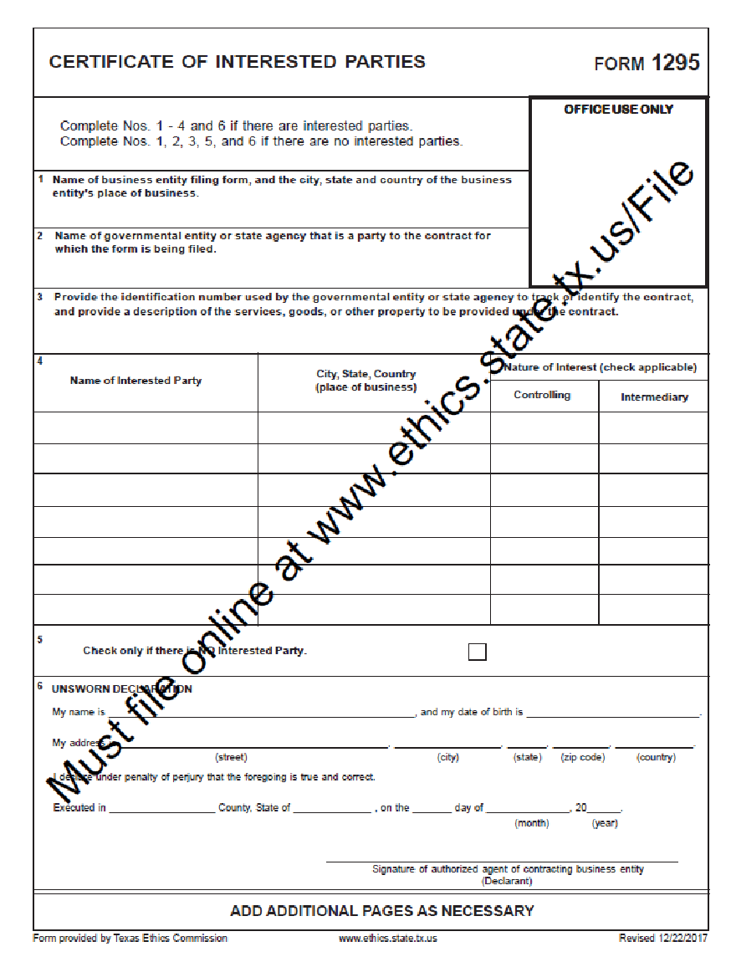

(To be completed by awarded vendor)

**REQUIRED CONTRACT PROVISIONS**

2 CFR 200.327 Contract provisions. The non-Federal entity's contracts should contain applicable provisions described in Appendix II to Part 200—Contract Provisions for non-Federal Entity Contracts Under Federal Awards. The non-Federal entity's contracts may contain the applicable provisions described in Appendix II to Part 200—Contract Provisions for non-Federal Entity Contracts Under Federal Awards. **\*Language as of May 21, 2021.**

**All Contracts**

|  |  |  |
| --- | --- | --- |
| **THRESHOLD** | **PROVISION** | **CITATION** |
| >$250,000  (Simplified Acquisition Threshold) | Contracts for more than the simplified acquisition threshold, which is the inflation adjusted amount determined by the Civilian Agency Acquisition Council and the Defense Acquisition Regulations Council (Councils) as authorized by 41 U.S.C. 1908, must address administrative, contractual, or legal remedies in instances where contractors violate or breach contract terms, and provide for such sanctions and penalties as appropriate. | 2 CFR 200  APPENDIX II (A) |
| >$10,000 | All contracts in excess of $10,000 must address termination for cause and for convenience by the non-Federal entity including the manner by which it will be effected and the basis for settlement. | 2 CFR 200  APPENDIX II (B) |
| None | Equal Employment Opportunity. Except as otherwise provided under 41 CFR Part 60, all contracts that meet the definition of ‘‘federally assisted construction contract’’ in 41 CFR Part 60–1.3 must include the equal opportunity clause provided under 41 CFR 60–1.4(b), in accordance with Executive Order 11246, ‘‘Equal Employment Opportunity’’ (30 FR 12319, 12935, 3 CFR Part, 1964–1965 Comp., p. 339), as amended by Executive Order 11375, ‘‘Amending Executive Order 11246 Relating to Equal Employment Opportunity,’’ and implementing regulations at 41 CFR part 60, ‘‘Office of Federal Contract Compliance Programs, Equal Employment Opportunity, Department of Labor.’’  41 CFR 60-1.4 Equal opportunity clause.  (b) Federally assisted construction contracts. (1) Except as otherwise provided, each administering agency shall require the inclusion of the following language as a condition of any grant, contract, loan, insurance, or guarantee involving federally assisted construction which is not exempt from the requirements of the equal opportunity clause:  The [recipient] hereby agrees that it will incorporate or cause to be incorporated into any contract for construction work, or modification thereof, as defined in the regulations of the Secretary of Labor at 41 CFR Chapter 60, which is paid for in whole or in part with funds obtained from the Federal Government or borrowed on the credit of the Federal Government pursuant to a grant, contract, loan, insurance, or guarantee, or undertaken pursuant to any Federal program involving such grant, contract, loan, insurance, or guarantee, the following equal opportunity clause:  During the performance of this contract, the contractor agrees as follows:  (1) The contractor will not discriminate against any employee or applicant for employment because of race, color, religion, sex, sexual orientation, gender identity, or national origin. The contractor will take affirmative action to ensure that applicants are employed, and that employees are treated during employment without regard to their race, color, religion, sex, sexual orientation, gender identity, or national origin. Such action shall include, but not be limited to the following:  Employment, upgrading, demotion, or transfer; recruitment or recruitment advertising; layoff or termination; rates of pay or other forms of compensation; and selection for training, including apprenticeship. The contractor agrees to post in conspicuous places, available to employees and applicants for employment, notices to be provided setting forth the provisions of this nondiscrimination clause.  (2) The contractor will, in all solicitations or advertisements for employees placed by or on behalf of the contractor, state that all qualified applicants will receive consideration for employment without regard to race, color, religion, sex, sexual orientation, gender identity, or national origin.  (3) The contractor will not discharge or in any other manner discriminate against any employee or applicant for employment because such employee or applicant has inquired about, discussed, or disclosed the compensation of the employee or applicant or another employee or applicant. This provision shall not apply to instances in which an employee who has access to the compensation information of other employees or applicants as a part of such employee's essential job functions discloses the compensation of such other employees or applicants to individuals who do not otherwise have access to such information, unless such disclosure is in response to a formal complaint or charge, in furtherance of an investigation, proceeding, hearing, or action, including an investigation conducted by the employer, or is consistent with the contractor's legal duty to furnish information.  (4) The contractor will send to each labor union or representative of workers with which he has a collective bargaining agreement or other contract or understanding, a notice to be provided advising the said labor union or workers' representatives of the contractor's commitments under this section, and shall post copies of the notice in conspicuous places available to employees and applicants for employment.  (5) The contractor will comply with all provisions of Executive Order 11246 of September 24, 1965, and of the rules, regulations, and relevant orders of the Secretary of Labor.  (6) The contractor will furnish all information and reports required by Executive Order 11246 of September 24, 1965, and by rules, regulations, and orders of the Secretary of Labor, or pursuant thereto, and will permit access to his books, records, and accounts by the administering agency and the Secretary of Labor for purposes of investigation to ascertain compliance with such rules, regulations, and orders.  (7) In the event of the contractor's noncompliance with the nondiscrimination clauses of this contract or with any of the said rules, regulations, or orders, this contract may be canceled, terminated, or suspended in whole or in part and the contractor may be declared ineligible for further Government contracts or federally assisted construction contracts in accordance with procedures authorized in Executive Order 11246 of September 24, 1965, and such other sanctions may be imposed and remedies invoked as provided in Executive Order 11246 of September 24, 1965, or by rule, regulation, or order of the Secretary of Labor, or as otherwise provided by law.  (8) The contractor will include the portion of the sentence immediately preceding paragraph (1) and the provisions of paragraphs (1) through (8) in every subcontract or purchase order unless exempted by rules, regulations, or orders of the Secretary of Labor issued pursuant to section 204 of Executive Order 11246 of September 24, 1965, so that such provisions will be binding upon each subcontractor or vendor. The contractor will take such action with respect to any subcontract or purchase order as the administering agency may direct as a means of enforcing such provisions, including sanctions for noncompliance:  Provided, however, that in the event a contractor becomes involved in, or is threatened with, litigation with a subcontractor or vendor as a result of such direction by the administering agency, the contractor may request the United States to enter into such litigation to protect the interests of the United States.  The [recipient] further agrees that it will be bound by the above equal opportunity clause with respect to its own employment practices when it participates in federally assisted construction work: Provided, that if the [recipient] so participating is a State or local government, the above equal opportunity clause is not applicable to any agency, instrumentality or subdivision of such government which does not participate in work on or under the contract.  The [recipient] agrees that it will assist and cooperate actively with the administering agency and the Secretary of Labor in obtaining the compliance of contractors and subcontractors with the equal opportunity clause and the rules, regulations, and relevant orders of the Secretary of Labor, that it will furnish the administering agency and the Secretary of Labor such information as they may require for the supervision of such compliance, and that it will otherwise assist the administering agency in the discharge of the agency's primary responsibility for securing compliance.  The [recipient] further agrees that it will refrain from entering into any contract or contract modification subject to Executive Order 11246 of September 24, 1965, with a contractor debarred from, or who has not demonstrated eligibility for, Government contracts and federally assisted construction contracts pursuant to the Executive Order and will carry out such sanctions and penalties for violation of the equal opportunity clause as may be imposed upon contractors and subcontractors by the administering agency or the Secretary of Labor pursuant to Part II, Subpart D of the Executive Order. In addition, the [recipient] agrees that if it fails or refuses to comply with these undertakings, the administering agency may take any or all of the following actions: Cancel, terminate, or suspend in whole or in part this grant (contract, loan, insurance, guarantee); refrain from extending any further assistance to the [recipient] under the program with respect to which the failure or refund occurred until satisfactory assurance of future compliance has been received from such [recipient]; and refer the case to the Department of Justice for appropriate legal proceedings. | 2 CFR 200  APPENDIX II (C) and 41 CFR §60-1.4(b) |
| >$2,000 | Davis-Bacon Act, as amended (40 U.S.C. 3141-3148). When required by Federal program legislation, all prime construction contracts in excess of $2,000 awarded by non-Federal entities must include a provision for compliance with the Davis-Bacon Act (40 U.S.C. 3141-3144, and 3146-3148) as supplemented by Department of Labor regulations (29 CFR Part 5, “Labor Standards Provisions Applicable to Contracts Covering Federally Financed and Assisted Construction”). In accordance with the statute, contractors must be required to pay wages to laborers and mechanics at a rate not less than the prevailing wages specified in a wage determination made by the Secretary of Labor. In addition, contractors must be required to pay wages not less than once a week. The non-Federal entity must place a copy of the current prevailing wage determination issued by the Department of Labor in each solicitation. The decision to award a contract or subcontract must be conditioned upon the acceptance of the wage determination. The non-Federal entity must report all suspected or reported violations to the Federal awarding agency. The contracts must also include a provision for compliance with the Copeland “Anti-Kickback” Act (40 U.S.C. 3145), as supplemented by Department of Labor regulations (29 CFR Part 3, “Contractors and Subcontractors on Public Building or Public Work Financed in Whole or in Part by Loans or Grants from the United States”). The Act provides that each contractor or subrecipient must be prohibited from inducing, by any means, any person employed in the construction, completion, or repair of public work, to give up any part of the compensation to which he or she is otherwise entitled. The non-Federal entity must report all suspected or reported violations to the Federal awarding agency. | 2 CFR 200  APPENDIX II (D) |
| >$100,000 | Contract Work Hours and Safety Standards Act (40 U.S.C. 3701-3708). Where applicable, all contracts awarded by the non-Federal entity in excess of $100,000 that involve the employment of mechanics or laborers must include a provision for compliance with 40 U.S.C. 3702 and 3704, as supplemented by Department of Labor regulations (29 CFR Part 5). Under 40 U.S.C. 3702 of the Act, each contractor must be required to compute the wages of every mechanic and laborer on the basis of a standard work week of 40 hours. Work in excess of the standard work week is permissible provided that the worker is compensated at a rate of not less than one and a half times the basic rate of pay for all hours worked in excess of 40 hours in the work week. The requirements of 40 U.S.C. 3704 are applicable to construction work and provide that no laborer or mechanic must be required to work in surroundings or under working conditions which are unsanitary, hazardous or dangerous. These requirements do not apply to the purchases of supplies or materials or articles ordinarily available on the open market, or contracts for transportation or transmission of intelligence. | 2 CFR 200  APPENDIX II (E) |
| None | Rights to Inventions Made Under a Contract or Agreement. If the Federal award meets the definition of “funding agreement” under 37 CFR §401.2 (a) and the recipient or recipient wishes to enter into a contract with a small business firm or nonprofit organization regarding the substitution of parties, assignment or performance of experimental, developmental, or research work under that “funding agreement,” the recipient or recipient must comply with the requirements of 37 CFR Part 401, “Rights to Inventions Made by Nonprofit Organizations and Small Business Firms Under Government Grants, Contracts and Cooperative Agreements,” and any implementing regulations issued by the awarding agency. | 2 CFR 200  APPENDIX II (F) |
| >$150,000 | Clean Air Act (42 U.S.C. 7401-7671q.) and the Federal Water Pollution Control Act (33 U.S.C. 1251-1387), as amended—Contracts and subgrants of amounts in excess of $150,000 must contain a provision that requires the non-Federal award to agree to comply with all applicable standards, orders or regulations issued pursuant to the Clean Air Act (42 U.S.C. 7401-7671q) and the Federal Water Pollution Control Act as amended (33 U.S.C. 1251-1387). Violations must be reported to the Federal awarding agency and the Regional Office of the Environmental Protection Agency (EPA). | 2 CFR 200  APPENDIX II (G) |
| None | Debarment and Suspension (Executive Orders 12549 and 12689)—A contract award (see 2 CFR 180.220) must not be made to parties listed on the governmentwide exclusions in the System for Award Management (SAM), in accordance with the OMB guidelines at 2 CFR 180 that implement Executive Orders 12549 (3 CFR part 1986 Comp., p. 189) and 12689 (3 CFR part 1989 Comp., p. 235), “Debarment and Suspension.” SAM Exclusions contains the names of parties debarred, suspended, or otherwise excluded by agencies, as well as parties declared ineligible under statutory or regulatory authority other than Executive Order 12549. | 2 CFR 200  APPENDIX II (H) |
| >$100,000 | Byrd Anti-Lobbying Amendment (31 U.S.C. 1352)—Contractors that apply or bid for an award exceeding $100,000 must file the required certification. Each tier certifies to the tier above that it will not and has not used Federal appropriated funds to pay any person or organization for influencing or attempting to influence an officer or employee of any agency, a member of Congress, officer or employee of Congress, or an employee of a member of Congress in connection with obtaining any Federal contract, grant or any other award covered by 31 U.S.C. 1352. Each tier must also disclose any lobbying with non-Federal funds that takes place in connection with obtaining any Federal award. Such disclosures are forwarded from tier to tier up to the non-Federal award. | 2 CFR 200  APPENDIX II (I)  and  24 CFR §570.303 |
|  | *See* 2 CFR §200.323. | 2 CFR 200  APPENDIX II (J) |
|  | *See* 2 CFR §200.316. | 2 CFR 200  APPENDIX II (K) |
|  | *See* 2 CFR §200.322. | 2 CFR 200  APPENDIX II (L) |
| None | The Federal awarding agency must establish conflict of interest policies for Federal awards. The non-Federal entity must disclose in writing any potential conflict of interest to the Federal awarding agency or pass-through entity in accordance with applicable Federal awarding agency policy. | 2 CFR 200.112 |
| None | The [Federal awarding agency](https://www.law.cornell.edu/definitions/index.php?width=840&height=800&iframe=true&def_id=3164f893d6d82447c92d899285ce22b2&term_occur=999&term_src=Title:2:Subtitle:A:Chapter:II:Part:200:Subpart:D:Subjgrp:31:200.336) and the [non-Federal entity](https://www.law.cornell.edu/definitions/index.php?width=840&height=800&iframe=true&def_id=de00dfd10f09071c905d0928428a197d&term_occur=999&term_src=Title:2:Subtitle:A:Chapter:II:Part:200:Subpart:D:Subjgrp:31:200.336) should, whenever practicable, collect, transmit, and store [Federal award](https://www.law.cornell.edu/definitions/index.php?width=840&height=800&iframe=true&def_id=081a194046528468942c369470c2966a&term_occur=999&term_src=Title:2:Subtitle:A:Chapter:II:Part:200:Subpart:D:Subjgrp:31:200.336)-related information in open and machine-readable formats rather than in closed formats or on paper in accordance with applicable legislative requirements. A machine-readable format is a format in a standard computer language (not English text) that can be read automatically by a web browser or computer system. The [Federal awarding agency](https://www.law.cornell.edu/definitions/index.php?width=840&height=800&iframe=true&def_id=3164f893d6d82447c92d899285ce22b2&term_occur=999&term_src=Title:2:Subtitle:A:Chapter:II:Part:200:Subpart:D:Subjgrp:31:200.336) or [pass-through entity](https://www.law.cornell.edu/definitions/index.php?width=840&height=800&iframe=true&def_id=d3c30c7fcabf85260bb176c07e6d95a5&term_occur=999&term_src=Title:2:Subtitle:A:Chapter:II:Part:200:Subpart:D:Subjgrp:31:200.336) must always provide or accept paper versions of [Federal award](https://www.law.cornell.edu/definitions/index.php?width=840&height=800&iframe=true&def_id=081a194046528468942c369470c2966a&term_occur=999&term_src=Title:2:Subtitle:A:Chapter:II:Part:200:Subpart:D:Subjgrp:31:200.336)-related information to and from the [non-Federal entity](https://www.law.cornell.edu/definitions/index.php?width=840&height=800&iframe=true&def_id=de00dfd10f09071c905d0928428a197d&term_occur=999&term_src=Title:2:Subtitle:A:Chapter:II:Part:200:Subpart:D:Subjgrp:31:200.336) upon request. If paper copies are submitted, the [Federal awarding agency](https://www.law.cornell.edu/definitions/index.php?width=840&height=800&iframe=true&def_id=3164f893d6d82447c92d899285ce22b2&term_occur=999&term_src=Title:2:Subtitle:A:Chapter:II:Part:200:Subpart:D:Subjgrp:31:200.336) or [pass-through entity](https://www.law.cornell.edu/definitions/index.php?width=840&height=800&iframe=true&def_id=d3c30c7fcabf85260bb176c07e6d95a5&term_occur=999&term_src=Title:2:Subtitle:A:Chapter:II:Part:200:Subpart:D:Subjgrp:31:200.336) must not require more than an original and two copies. When original records are electronic and cannot be altered, there is no need to create and retain paper copies. When original records are paper, electronic versions may be substituted through the use of duplication or other forms of electronic media provided that they are subject to periodic quality control reviews, provide reasonable safeguards against alteration, and remain readable. | 2 CFR 200.336 |
| None | Contracting with HUB, small and minority businesses, women's business enterprises, and labor surplus area firms.  (a) The non-Federal entity must take all necessary affirmative steps to assure that minority businesses, women's business enterprises, and labor surplus area firms are used when possible.  (b) Affirmative steps must include:  (1) Placing qualified small and minority businesses and women's business enterprises on solicitation lists;  (2) Assuring that small and minority businesses, and women's business enterprises are solicited whenever they are potential sources;  (3) Dividing total requirements, when economically feasible, into smaller tasks or quantities to permit maximum participation by small and minority businesses, and women's business enterprises;  (4) Establishing delivery schedules, where the requirement permits, which encourage participation by small and minority businesses, and women's business enterprises;  (5) Using the services and assistance, as appropriate, of such organizations as the Small Business Administration and the Minority Business Development Agency of the Department of Commerce; and  (6) Requiring the prime contractor, if subcontracts are to be let, to take the affirmative steps listed in paragraphs (1) through (5) of this section. | 2 CFR 200.321 |
| None | Financial records, supporting documents, statistical records, and all other non-Federal entity records pertinent to a Federal award must be retained for a period of three years from the date of submission of the final expenditure report or, for Federal awards that are renewed quarterly or annually, from the date of the submission of the quarterly or annual financial report, respectively, as reported to the Federal awarding agency or pass-through entity in the case of a recipient. Federal awarding agencies and pass-through entities must not impose any other record retention requirements upon non-Federal entities. The only exceptions are the following:  (a) If any litigation, claim, or audit is started before the expiration of the 3-year period, the records must be retained until all litigation, claims, or audit findings involving the records have been resolved and final action taken.  (b) When the non-Federal entity is notified in writing by the Federal awarding agency, cognizant agency for audit, oversight agency for audit, cognizant agency for indirect costs, or pass-through entity to extend the retention period.  (c) Records for real property and equipment acquired with Federal funds must be retained for 3 years after final disposition.  (d) When records are transferred to or maintained by the Federal awarding agency or pass-through entity, the 3-year retention requirement is not applicable to the non-Federal entity.  (e) Records for program income transactions after the period of performance. In some cases, recipients must report program income after the period of performance. Where there is such a requirement, the retention period for the records pertaining to the earning of the program income starts from the end of the non-Federal entity's fiscal year in which the program income is earned.  (f) Indirect cost rate proposals and cost allocations plans. This paragraph applies to the following types of documents and their supporting records: indirect cost rate computations or proposals, cost allocation plans, and any similar accounting computations of the rate at which a particular group of costs is chargeable (such as computer usage chargeback rates or composite fringe benefit rates).  (1) If submitted for negotiation. If the proposal, plan, or other computation is required to be submitted to the Federal Government (or to the pass-through entity) to form the basis for negotiation of the rate, then the 3-year retention period for its supporting records starts from the date of such submission.  (2) If not submitted for negotiation. If the proposal, plan, or other computation is not required to be submitted to the Federal Government (or to the pass-through entity) for negotiation purposes, then the 3-year retention period for the proposal, plan, or computation and its supporting records starts from the end of the fiscal year (or other accounting period) covered by the proposal, plan, or other computation. | 2 CFR 200.334 |
| None | CONTRACTS WITH COMPANIES ENGAGED IN BUSINESS WITH IRAN, SUDAN, OR FOREIGN TERRORIST ORGANIZATION PROHIBITED. A governmental entity may not enter into a governmental contract with a company that is identified on a list prepared and maintained under Section 806.051, 807.051, or [2252.153](http://www.statutes.legis.state.tx.us/GetStatute.aspx?Code=GV&Value=2252.153).The term "foreign terrorist organization" in this paragraph has the meaning assigned to such a term in Section 2252.151(2) of the Texas Government Code. | Texas Government Code 2252.152 |
| >$100,000 | PROVISION REQUIRED IN CONTRACT. (a) This section applies only to a contract that:  (1) is between a governmental entity and a company with 10 or more full-time employees; and  (2) has a value of $100,000 or more that is to be paid wholly or partly from public funds of the governmental entity.  (b) A governmental entity may not enter into a contract with a company for goods or services unless the contract contains a written verification from the company that it:  (1) does not boycott Israel; and  (2) will not boycott Israel during the term of the contract. | Texas Government Code 2271 |
| Option Contract Language for contracts awarded prior to Grant Award | The contract award is contingent upon the receipt of ARP Act funds. If no such funds are awarded, the contract shall terminate. | Optional |
|  | Mandatory standards and policies relating to energy efficiency which are contained in the state energy conservation plan issued in compliance with the Energy Policy and Conservation Act. | 42 U.S.C. 6201 |